Zeyu Shen

Program 2 report

2017/4/20

--------Part1

please enter a number N

3000

At i=8; gcd(5,8) = 1 took 4 modulus operations time = 0.001 ms.

At i=195; gcd(89,144) = 1 took 10 modulus operations time = 0.019 ms.

At i=382; gcd(233,377) = 1 took 12 modulus operations time = 0.045 ms.

At i=569; gcd(233,377) = 1 took 12 modulus operations time = 0.07 ms.

At i=756; gcd(377,610) = 1 took 13 modulus operations time = 0.078 ms.

At i=943; gcd(377,610) = 1 took 13 modulus operations time = 0.102 ms.

At i=1130; gcd(610,987) = 1 took 14 modulus operations time = 0.114 ms.

At i=1317; gcd(610,987) = 1 took 14 modulus operations time = 0.129 ms.

At i=1504; gcd(610,987) = 1 took 14 modulus operations time = 0.132 ms.

At i=1691; gcd(987,1597) = 1 took 15 modulus operations time = 0.15 ms.

At i=1878; gcd(987,1597) = 1 took 15 modulus operations time = 0.142 ms.

At i=2065; gcd(987,1597) = 1 took 15 modulus operations time = 0.151 ms.

At i=2252; gcd(987,1597) = 1 took 15 modulus operations time = 0.157 ms.

At i=2439; gcd(987,1597) = 1 took 15 modulus operations time = 0.159 ms.

At i=2626; gcd(1597,2584) = 1 took 16 modulus operations time = 0.162 ms.

At i=2813; gcd(1597,2584) = 1 took 16 modulus operations time = 0.182 ms.

At i=3000; gcd(1597,2584) = 1 took 16 modulus operations time = 0.172 ms.

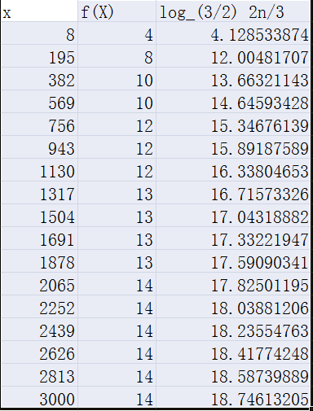

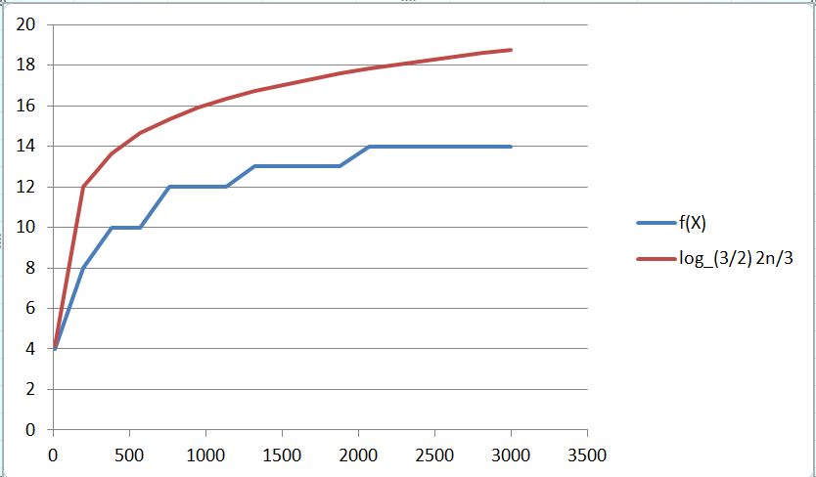

--------Part2

